Nabila Alia Zahra | Rangkuman Minggu 11 Pengaplikasian Arduino menggunakan Tinkercad | Senin, 14 November 2022
Nabila Alia Zahra |  | 16TNK5043 ( Aplikasi Mikrokontroler)
3NK |  | Ferry Satria, BSEE.,M.T.  Rahmawati Hasanah,S.ST.,M.T.

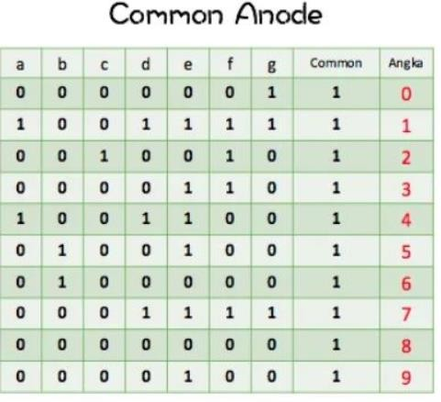

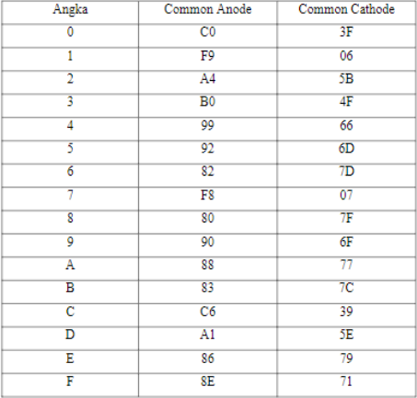

Up Down Counter 0-F

int pola[]={0XC0, 0X79, 0X24, 0XB0, 0X99, 0X12, 0X82, 0XF8, 0X80, 0X98, 0X88, 0X83, 0XC6, 0XA1, 0X86, 0X8E };
int i,x;
int pin[7]={7,8,9,10,11,12,13};
int pos[7]={1,2,4,8,0X10,0X20,0X40};
int mode,j=0; void setup()
{ pinMode(6,INPUT); for(i=0; i<7; i++)
pinMode(pin[i], OUTPUT);} void display(int data)
{ x = pola[data]; for(i=0; i<7; i++)
digitalWrite(pin[i], x & pos[i]);} void loop()
{ mode = digitalRead(6); if(mode==HIGH)
{j++; if(j>15) {j=0;}}
else
{j--; if(j<0) {j=15;}
}
display(j); delay(500);
}

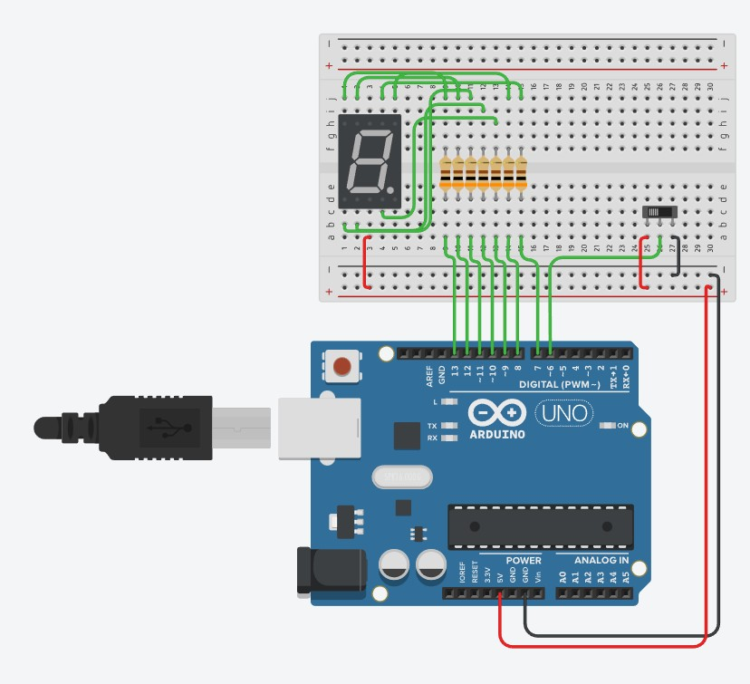

Up Down Counter Mod 10
int pola[]={0XC0, 0X79, 0X24, 0XB0, 0X99, 0X12, 0X82, 0XF8, 0X80, 0X98};
int i,x;
int pin[7]={7,8,9,10,11,12,13};
int pos[7]={1,2,4,8,0X10,0X20,0X40};
int mode,j=0; void setup()
{ pinMode(6,INPUT); for(i=0; i<7; i++)
pinMode(pin[i], OUTPUT);} void display(int data)
{ x = pola[data]; for(i=0; i<7; i++)
digitalWrite(pin[i], x & pos[i]);} void loop()
{ mode = digitalRead(6); if(mode==HIGH)
{j++; if(j>15) {j=0;}}
else
{j--; if(j<0) {j=15;}
}
display(j); delay(700);
}

DOT MATRIK LAB
.INCLUDE "M8535DEF.INC"
.ORG 0X00
.EQU TIMER_1=0XFF98 RJMP MAIN

.ORG 0X80 DAT:
.DB 0X30,0X36,0X36,0X36,0X6,0
.DB 0X10,8,4,2,1

MAIN:LDI R16,LOW (RAMEND)
OUT SPL, R16
LDI R16, HIGH (RAMEND) OUT SPH, R16

LDI R16,0XFF OUT DDRA,R16 OUT DDRB,R16

LDI R17,6 LL0: LDI R18,5
LDI R30,LOW(2*DAT) LDI R31,HIGH(2*DAT)

LL1: LPM R16,Z
OUT PORTB,R16 ADD R30,R17

LPM R16,Z
OUT PORTA,R16 RCALL D_2MS SUB R30,R17 INC R30
DEC R18 BRNE LL1 RJMP LL0

;----------SUBRUTIN DELAY 2MS-----------
D_2MS: PUSH R16 PUSH R17 LDI R16,1
OUT TIMSK,R16
LDI R16, HIGH(TIMER_1) OUT TCNT1H,R16
LDI R16, LOW(TIMER_1) OUT TCNT1L,R16
LDI R16,5
OUT TCCR1B,R16

LT:
IN R17,TIFR SBRS R17,TOV1 RJMP LT
LDI R16,4 OUT TIFR,R16 POP R17
POP R16 RET

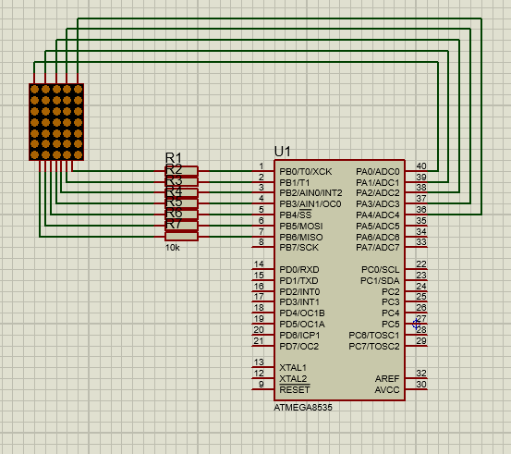
LCD
#include <LiquidCrystal.h>

const int rs=12,en=11,d4=5, d5=4, d6=3,d7=2;
LiquidCrystal lcd(rs,en,d4,d5,d6,d7); // mesign nilai yg ada diatasnya int i,x=0; // inisialisasi nilai i dan x
void setup()
{
lcd.begin(16,2); // lcd.setCursor(0,0);
lcd.print("Halo, apa kabar?"); //menampulkan huruf atau angka lcd.setCursor(0,1);
lcd.print("Saya Donny");delay(4000); // mencetak huruf atau angka, ada delaynya

}

void loop()
{ lcd.clear(); //menghapus

lcd.setCursor(0,0); // menset ada di baris 1, nanti berpindah kebaris yang lainnya for(i=x; i<=x+7; i++) // nyetak 2 digit 2 digit
{if(i>99)break; //
lcd.print(i); // mencetak huruf atau angka delay(700);
}
lcd.setCursor(0,1);
for(i=x+8; i<=x+15; i++) // nyetak 1 digit 1 digit
{if(i>99)break;

lcd.print(i); delay(700);
}
x=i; if(x>99)x=0;
}

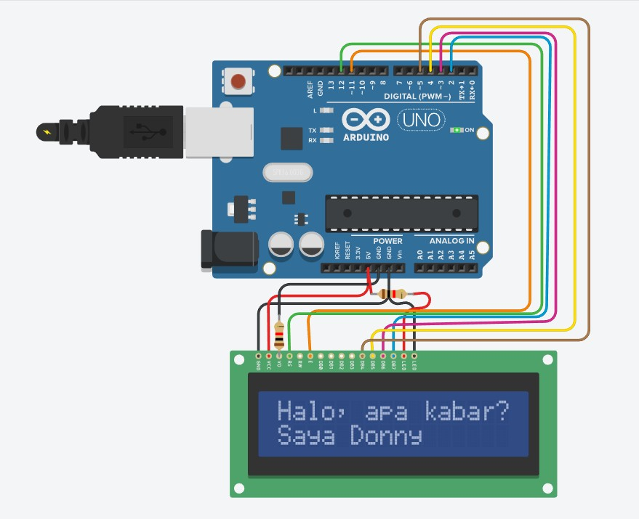

Latihan Soal
- Membuat program menampilkan kata “BISA” bergerak bolak balik (kekiri dan kekanan setiap 5 kali) dari baris 1 ke baris 2 secara berulang. Tentukan sendiri kecepatan pergerakannya
#include <LiquidCrystal.h>

const int rs=12,en=11,d4=5, d5=4, d6=3,d7=2; LiquidCrystal lcd(rs,en,d4,d5,d6,d7);
int i,x=0; void setup()
{
lcd.begin(16,2);
}

void loop() { lcd.setCursor(0,0); lcd.print("BISA");
for (i=0 ; i<=11; i++) { lcd.scrollDisplayRight(); delay(50);
}
for (i=0 ; i<=11; i++) { lcd.scrollDisplayLeft(); delay(50);
}
for (i=0 ; i<=11; i++) { lcd.scrollDisplayRight(); delay(50);
}
for (i=0 ; i<=11; i++) { lcd.scrollDisplayLeft(); delay(50);
}
for (i=0 ; i<=11; i++) { lcd.scrollDisplayRight(); delay(50);
}
for (i=0 ; i<=11; i++) { lcd.scrollDisplayLeft(); delay(50);
}
for (i=0 ; i<=11; i++) { lcd.scrollDisplayRight(); delay(50);
}
for (i=0 ; i<=11; i++) { lcd.scrollDisplayLeft(); delay(50);
}

for (i=0 ; i<=11; i++) { lcd.scrollDisplayRight(); delay(50);
}
for (i=0 ; i<=11; i++) { lcd.scrollDisplayLeft(); delay(50);
}
lcd.clear(); lcd.setCursor(0,1); lcd.print("BISA");
for (i=0 ; i<=11; i++) { lcd.scrollDisplayRight(); delay(50);
}
for (i=0 ; i<=11; i++) { lcd.scrollDisplayLeft(); delay(50);
}
for (i=0 ; i<=11; i++) { lcd.scrollDisplayRight(); delay(50);
}
for (i=0 ; i<=11; i++) { lcd.scrollDisplayLeft(); delay(50);
}
for (i=0 ; i<=11; i++) { lcd.scrollDisplayRight(); delay(50);
}
for (i=0 ; i<=11; i++) { lcd.scrollDisplayLeft(); delay(50);
}
for (i=0 ; i<=11; i++) { lcd.scrollDisplayRight(); delay(50);
}
for (i=0 ; i<=11; i++) { lcd.scrollDisplayLeft(); delay(50);
}
for (i=0 ; i<=11; i++) { lcd.scrollDisplayRight(); delay(50);
}
for (i=0 ; i<=11; i++) { lcd.scrollDisplayLeft(); delay(50);

}
lcd.clear();
}
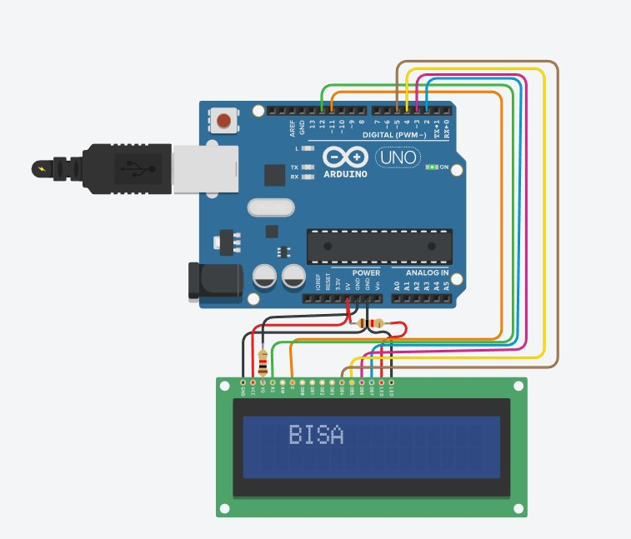

- Membuat 4 counter ( menghitung naik secara berulang ), Tentukan sendiri kecepatan pergerakannya
  - Ujung kiri atas up counter desimal mod 10
  - Ujung kanan atas up counter desimal mod 100
  - Ujung kiri bawah down counter HD mod 16
  - Ujung kanan bawah down counter HD mod 256 (FF-00)

- Membuat program seperti soal no 1, selain bergerak tapi berkedip juga
#include <LiquidCrystal.h>

const int rs=12,en=11,d4=5, d5=4, d6=3,d7=2; LiquidCrystal lcd(rs,en,d4,d5,d6,d7);
int i,x=0;

void setup() { lcd.begin(16, 2);

}

void loop() { lcd.setCursor(0,0); lcd.print("BISA");

for (int positionCounter = 0; positionCounter < 12; positionCounter++) { lcd.scrollDisplayRight();
delay(50); lcd.noDisplay(); delay(50); lcd.display(); delay(50);
}

for (int positionCounter = 0; positionCounter < 12; positionCounter++) { lcd.scrollDisplayLeft();
delay(50); lcd.noDisplay(); delay(50); lcd.display(); delay(50);
}

for (int positionCounter = 0; positionCounter < 12; positionCounter++) { lcd.scrollDisplayRight();
delay(50); lcd.noDisplay(); delay(50); lcd.display(); delay(50);
}

for (int positionCounter = 0; positionCounter < 12; positionCounter++) { lcd.scrollDisplayLeft();
delay(50); lcd.noDisplay(); delay(50); lcd.display(); delay(50);
}

for (int positionCounter = 0; positionCounter < 12; positionCounter++) { lcd.scrollDisplayRight();
delay(50); lcd.noDisplay(); delay(50); lcd.display(); delay(50);
}

lcd.clear();

lcd.setCursor(0,1); lcd.print("BISA");

for (int positionCounter = 0; positionCounter < 12; positionCounter++) { lcd.scrollDisplayRight();
delay(50); lcd.noDisplay(); delay(50); lcd.display(); delay(50);
}

for (int positionCounter = 0; positionCounter < 12; positionCounter++) { lcd.scrollDisplayLeft();
delay(50); lcd.noDisplay(); delay(50); lcd.display(); delay(50);
}

for (int positionCounter = 0; positionCounter < 12; positionCounter++) { lcd.scrollDisplayRight();
delay(50); lcd.noDisplay(); delay(50); lcd.display(); delay(50);
}

for (int positionCounter = 0; positionCounter < 12; positionCounter++) { lcd.scrollDisplayLeft();
delay(50); lcd.noDisplay(); delay(50); lcd.display(); delay(50);
}

for (int positionCounter = 0; positionCounter < 12; positionCounter++) { lcd.scrollDisplayRight();
delay(50); lcd.noDisplay(); delay(50); lcd.display(); delay(50);
}

lcd.clear(); delay(150);
}
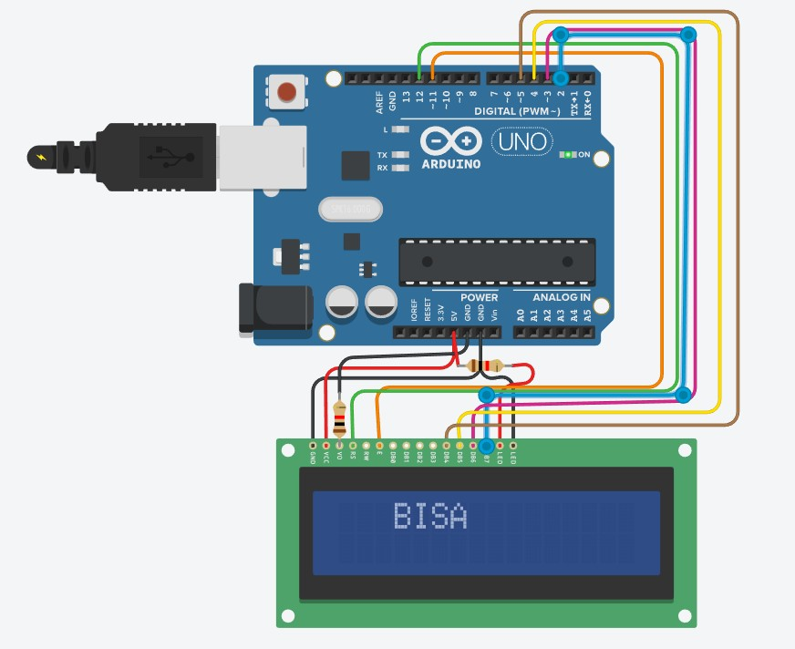

- Membuat program UP/Down counter desimal mod 100 (00-99) yang mode up/downnya dikendalikan secara polling (pilih sendiri) pin untuk menghubungkan push button pollingnya.

